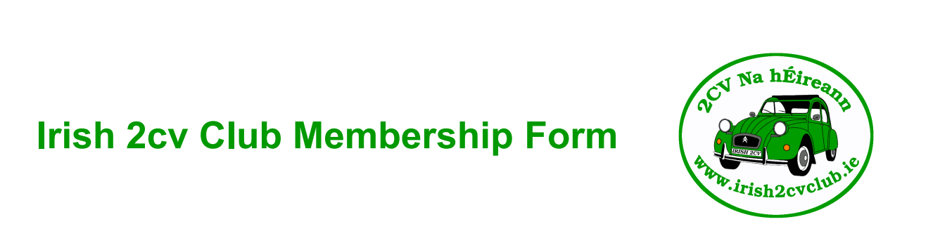
 | 2026 membership
Name:
Address:
Phone number:
Email: | Please use block letters
Signature:

How would you like to be contacted regarding upcoming runs and events?
Email WhatsApp
Do you want to be a member of WhatsApp Member Discussion group? YES / NO
Car Details | 1 | 2 | 3
Reg Number
Car Model
Car Year
Car Colour

Post/ Email or WhatsApp your membership form to: 2cvireland@gmail.com or 086 811 5665
Irish 2cv Club, Sean Doherty, The old bog road, Kilcock, Co. Kildare. W23 CK24

Please remember to enclose €20 Membership Fee. Cheque or postal order should be made payable to “Irish 2cv Club”. Alternatively, you can pay membership by Bank Transfer or Revolut to @seanmary3.
Please Tick payment method here: BANK TRANSFER REVOLUT CASH CHEQUE
Bank: Permanent TSB, Skibbereen, County Cork. Account Name: Irish 2CV club
BIC: IPBSIE2D IBAN: IE44IPBS99071722834051
Office use only | Club Number | Payment date | Payment method

